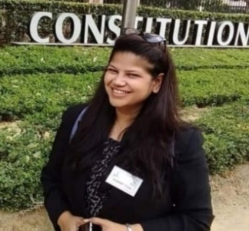

RASHI SINGH

EDUCATOR

singh16rashi@gmail.com|9560378566

**COVER LETTER**

I am Rashi Singh, native of Bareilly, Uttar Pradesh, presently residing in New Delhi for career prospects, have graduated in Environment and Chemistry and Bachelor’s in Education and completed Master’s in Applied Microbiology and Biotechnology and Anthropology. I am an Educator working since 2020 as a faculty of UPSC GS Science and Technology and Environment, also having Experience **of 2+ years for teaching and mentorship.**

**EXPERIENCE SUMMARY**

**EXPERIENCE SUMMARY**

1. Working as a Mentor at Chahal Academy 11th November 2023
2. July 2020- March 2023 at The Prayas India Mumbai
   1. Worked as Faculty of GS Science and Technology, Environment in offline and Online Mode For UPSC.
   2. Worked as Faculty of GS in Online mode for NDA.
   3. Worked as faculty for UPSC GS History at Ranchi Branch in Offline mode.
   4. Worked as a Mentor of SSB (Service Selection Board) Interview.
3. Pt Deenanath Mishr Senior Secondary School, Bareilly 2021
   1. Worked as a Faculty of Science from class 8th to 10th and Biology for Class 12th.
4. Selected for BYJU’s Mentorship ProgramJune 2019 but due to job location at Bangalore.
5. CPL SYS IAS 2019- 2020
   1. Worked as Content Writer for Science and Technology and Environment.
6. Worked with Padho Padao.Com home tuitions since 2014, till now have tutored more than 60 students.
7. Taught Science and Biotechnology in 2016 year with Pandey coaching in west Patel Nagar for 9th to 12th class.

**QUALIFICATIONS**

|  |  |
| --- | --- |
| **SNO.** | **PARTICULARS** |
| 1. | **BAREILLY COLLEGE BAREILLY**  BACHELOR’S IN ENVIRONMENT AND CHEMISTRY 2011 |
| 2. | **BANASTHALI VIDYAPEETH RAJASTHAN**  MASTER’S IN APPLIED MICROBIOLOGY AND BIOTECHNOLOGY 2014 |
| 3. | **MJP ROHILKHAND UNIVERSITY BAREILLY**  BACHELORS IN EDUCATION 2023 |
| 4. | **IGNOU**  MASTERS IN ANTHROPOLOGY 2023 |
| 5. | **WOOD ROW SENIOR SECONDARY SCHOOL BAREILLY**  12TH 2008 |
| 6. | **ARMY PUBLIC SCHOOL**  10TH 2006 |

**SKILLS**

* Content & Article writing.
* Educating videos on Instagram and YouTube
* Conducting Webinars and live educational seminars.

Yours truly Bareilly

Rashi Singh 9-1-2024